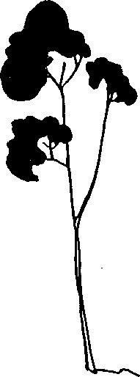
Country Day Montessori School
2021-2022
Application and Enrollment Process

New Students

Welcome! Selecting your child’s educational path is one of the most important decisions you will make as a parent. We understand every school is unique. Country Day Montessori's long history in the area, combined with the many opportunities for family engagement and friendship, has helped to evolve CDM into a strong community. We think of it as enrolling families, not just students, and our goal is to create a mutually beneficial relationship with many opportunities for whole family engagement. Please visit our website for more information

We invite you to take the first step in our admission process:

- Schedule an observation if you have not done so already. We are currently signing up for virtual observations until the stay at home order is lifted. There is no better way to understand the unique strategy of a Montessori program than to experience it yourself.
- Submit an Application with a non-refundable $75.00 fee

We will review your application and enroll your child as space is available. If CDM is at capacity, we will place your child's name on an appropriate wait list. We will do this according to your desired start date and the child's age. When an opening occurs, the parent/guardian will be contacted. Once a placement has been offered, parents have 72 hours (3 days) to contact the school and accept/decline the position. Please remember, it is the Applicant's responsibility to keep contact information updated. Upon acceptance, you will receive an admission agreement via email.

- Please fill out the agreement and return it to CDM with the one time enrollment fee of $75.00 and the $100.00 annual materials fee ($175.00 total).

It is important to understand that your child cannot be guaranteed a slot at
CDM until the Admission Agreement is returned to us and Enrollment and Annual fees are submitted.

We are excited you are considering Country Day Montessori and look forward to growing with your child and your family!

Country Day Montessori ● 2227 Spear Street. Placerville, California 95667 ● 530-626-1202

