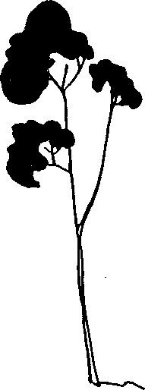
Country Day Montessori School
2021- 2022 Re Enrollment Form
DUE April 9, 2021
We are honored to have your family remain a part of our community. It is a joy to assist your child in his/her development. Thank you for your continued support.
In order to secure your child's placement in the program, this form and the annual fee, must be received by April 9, 2021. After April 9, we will begin enrolling children from our wait list. As always, we are here to answer any questions.

Today’s Date: ___​_________

Name of Child________________________________________________Birthdate:_________________
Please indicate program of interest:
_____ 5 Day Program Monday - Friday 9:00 a.m. - 3:00 p.m. $685
_____ 3 Day Program Monday, Tuesday, Wednesday, 9:00 a.m. - 3:00 p.m. $625 *Space in 3 Day Program is limited and reserved for our youngest applicants
Add on care:
_____ Morning extended care: 7:30 am - 9:00 am $ 75
_____ After school care: 3:00 pm - 5:30 pm $135
Parent Signature: _________________________________________________________________
Please submit $100.00 non-refundable annual fee with this form.
First tuition payment is due on or before August 1, 2021
==================================================================================================================

❏ Re-enrollment rcvd _________ (date) Fee rcvd ____________ (check #) Updated forms sent

